**Introduction to the feasibility analysis of the Go-Safe:-**

The main objective of the feasibility analysis is to see whether out idea will achieve the goals or not. The way to test whether the given idea is feasible or not by using the Economic, Technological, and many more analysis. Which will tell will this idea (Go-Safe) of our will succeed or not. We are going to be the new people new in this area and needed to compete with much evolved organizations so we focused on following aspects :-

1. **Technical Feasibility :-**

The only hardware required for our web based project is a Server for hosting and computer to handle some query over the web. Since we will be upgrading the website over the time as per the requirements.

1. **Operation Feasibility :-**

This is an important aspect in this type of organization. The main aspects like the Go-safe support center (for contacting), no server crashing due to large number of users. The new technology needed for this website are low cost but with the increase in data traffic

1. **Economic Feasibility :-**

In the Economic Feasibility, we are making a server over a free website hosting service, so as if want to make a test for the website. After that we will make it permanent given by the charges over that hosting site.

1. **Behavioral Feasibility :-**

We have mainly focused on the UI, making it friendly as for customer and the manager using the website. So that they don’t need any external experience for doing so. Although we have provided the helpline for any query.

1. **People’s opinion, their suggestion and their commitment to use the website. :-**

We have conducted a survey in the online Google Docs and circulated it. We gave some small and MCQ questions, over which we got many responses. Slice our main objective is of cab booking and sharing. The below charts say all, we have a opportunity to exile in the market. As many customers are in need of the idea we have. Many people opted for sharing cab feature as this is best to have where the group of customers go for job and wanted to share a cab for travelling. As we are having a online booking this reduces the customers phone contacts with drivers as the customer can book the cab online.

Here I have added some pie charts of responses that we got from people:-

1. Responses for question 1 :-

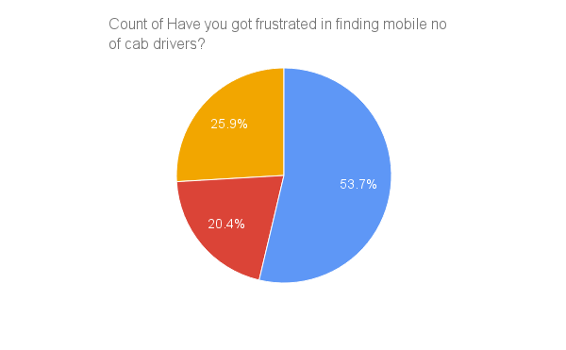

1. Responses for question 2 :-

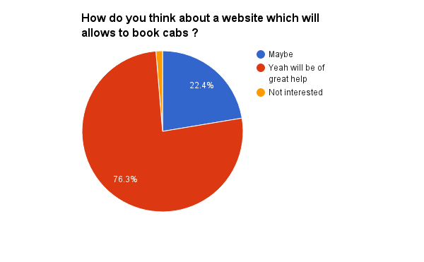

1. Responses for question 3 :-

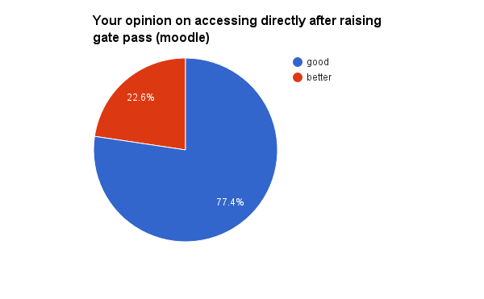

1. Responses for question 4 :-

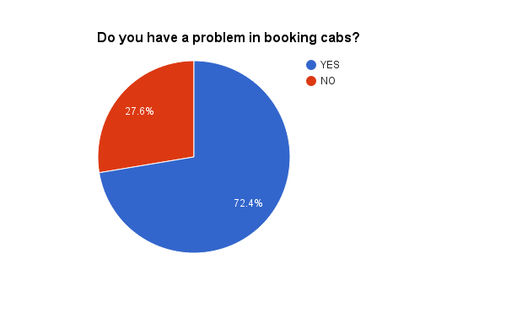

1. Responses for question 5 :-

